Learner Details

Total Study Time:

5:40:17

[18dce136@charusat.edu.in](mailto:18dce136@charusat.edu.in)

E-mail:

Name:

Mihir Vaishnav

Certified Courses

India

Country:

Introduction to Unit Testing in iOS App Development

## Score

95%

Completed On

2020-10-21

iOS app development is a booming industry. Having the ability to create industry standard, robust applications is seen as a huge benefit to employers. This course begins by introducing you to the concept of Unit Testing in programming and highlights the importance of it in iOS development. The course then outlines how unit testing is the breaking down of code into separate components and testing each individual component to ensure each performs as designed.

# Job Search Skills - Preparing Your Resume and Cover Letter - Revised

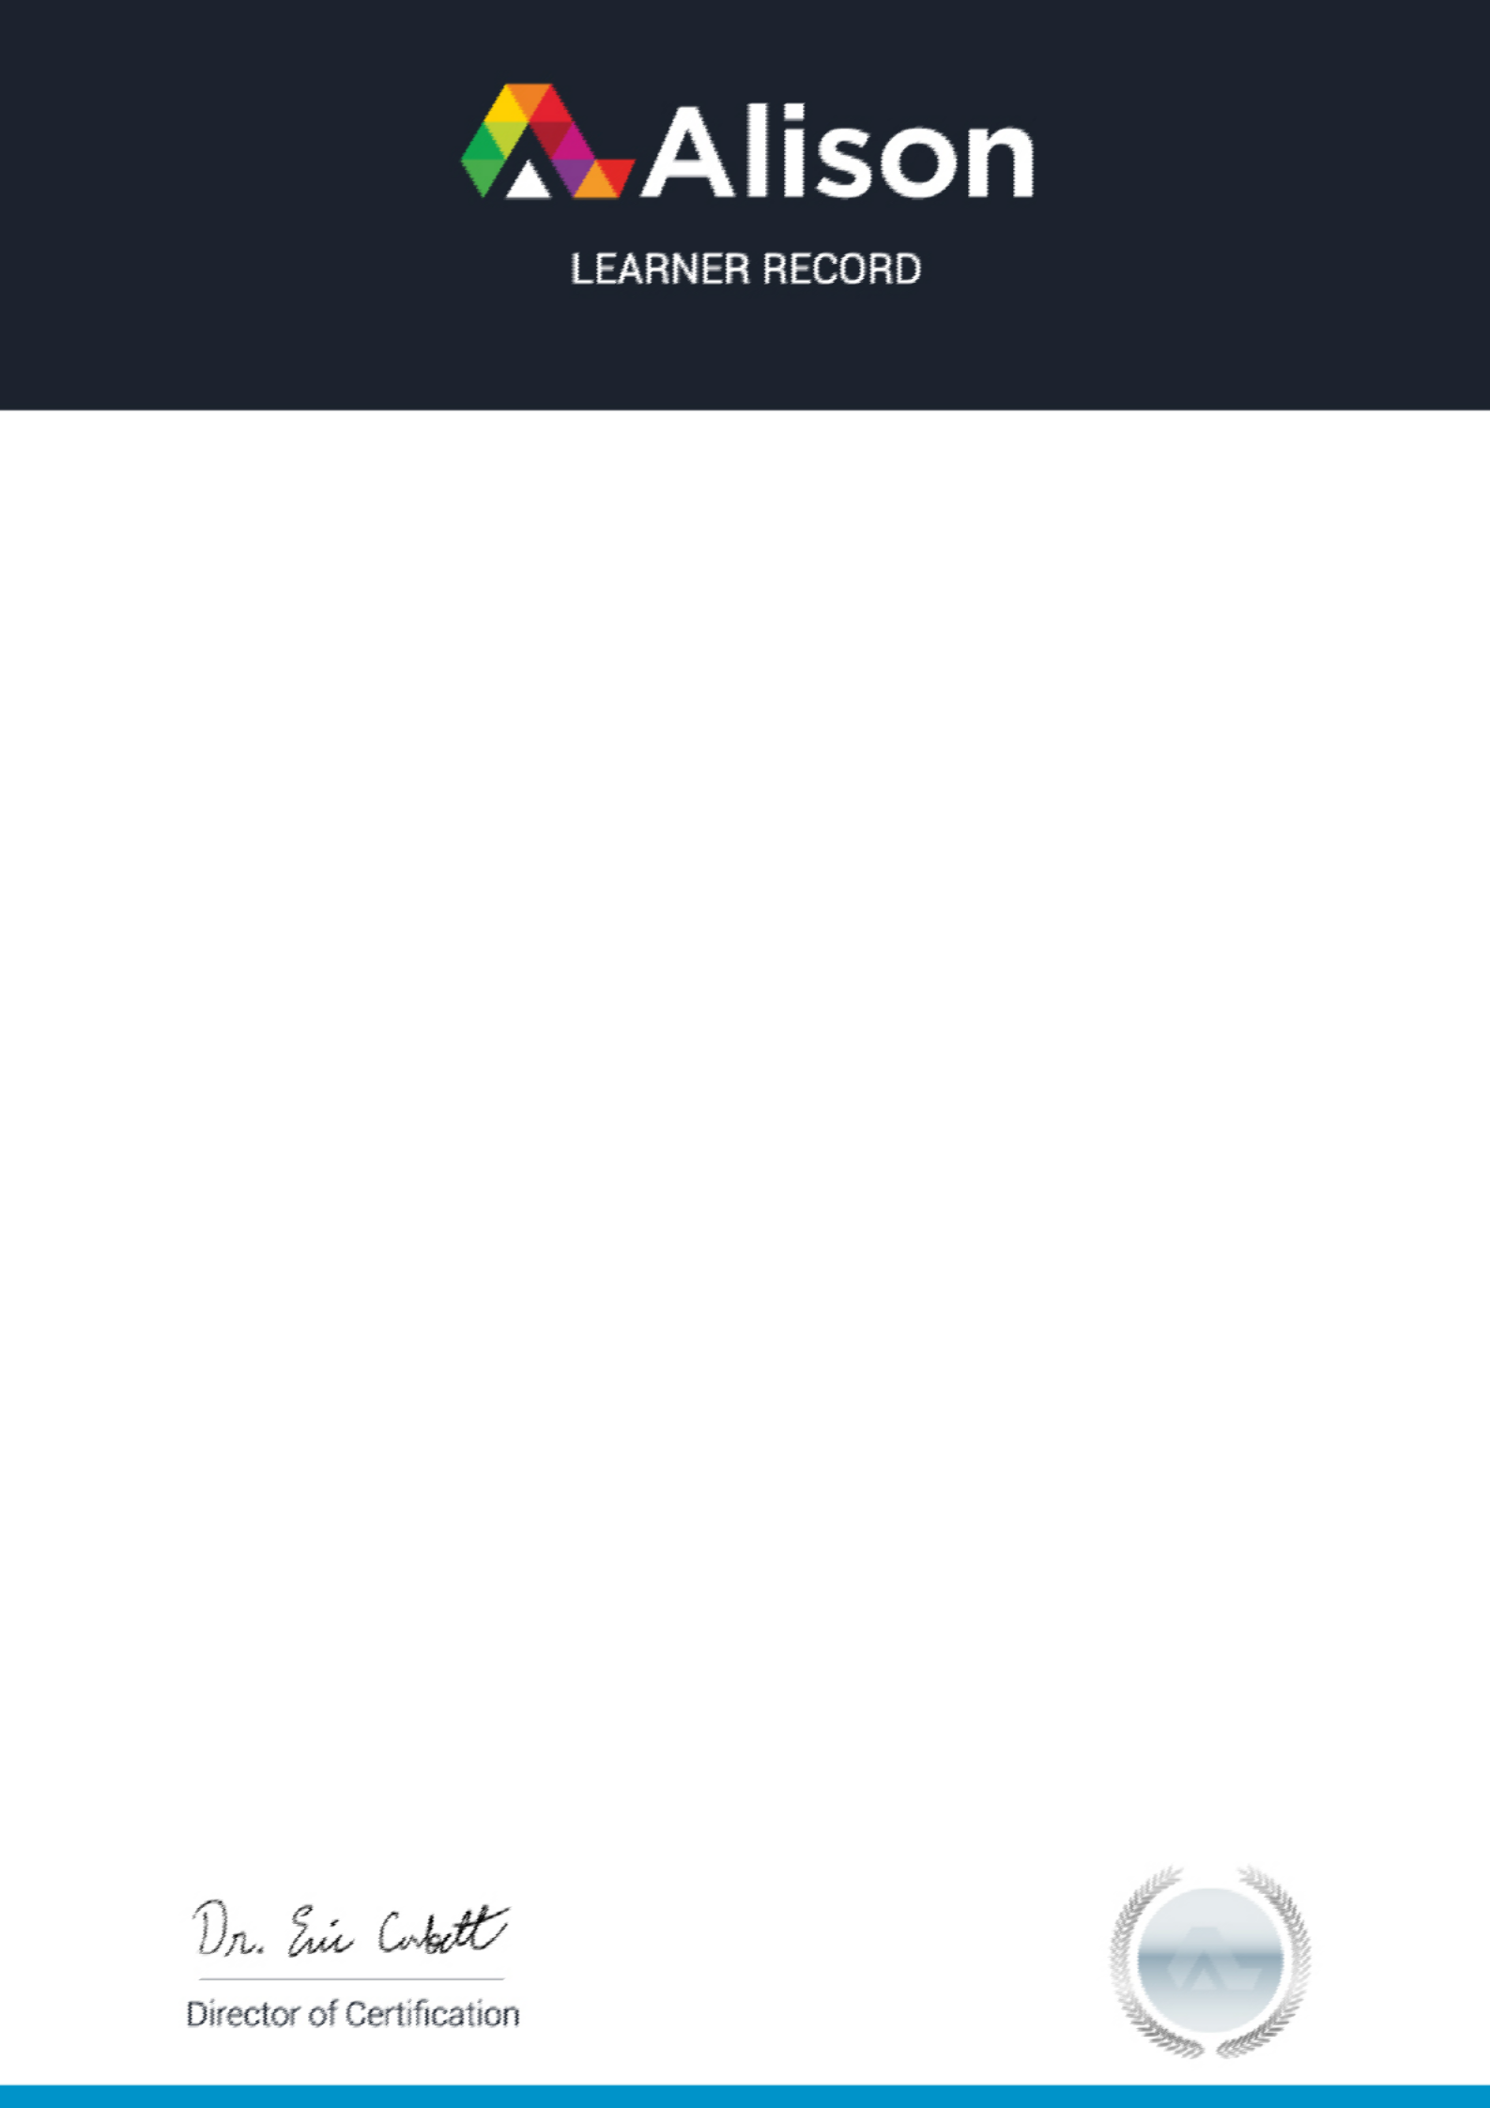

## Score

88%

Completed On

2020-09-09

The course first breaks down the job application process, so you can ensure that you identify and apply for the right job. It then goes through the essential elements of a resume showing you how to design a professional header and layout, write a concise outline of your background, and format your resume differently depending on what kind of job you are applying for. The course then goes through cover letter planning and design, before giving you examples for you to work with.